Q-1. Write an SQL query to fetch “FIRST_NAME” from Worker table using the alias name as <WORKER_NAME>.

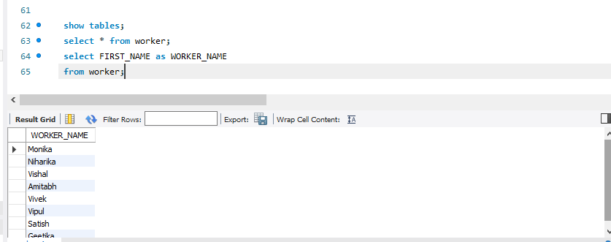

2. Write an SQL query to fetch unique values of DEPARTMENT from Worker table.
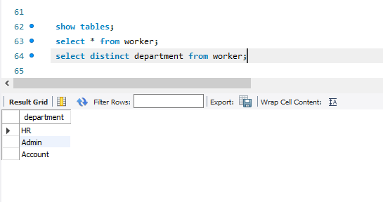

Q-3. Write an SQL query to show the last 5 record from a table.
